**DNA and reproductive systems practice test**

**NAME:**  **TOTAL ____ /54 = ____%**

***MULTIPLE CHOICE SECTION [10 MARKS]***

The next **THREE** questions refer to the diagram below:

C

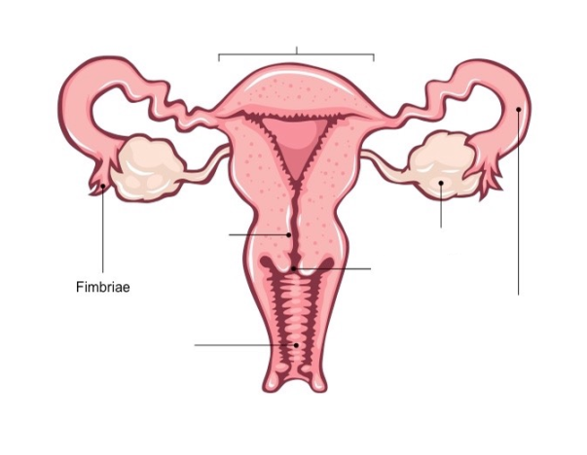

B

A

E

D

1. The structure that produces the ovum is:
2. A
3. B
4. C
5. E
6. The structure where fertilisation takes place is:
7. A
8. B
9. D
10. E
11. The Part C in the diagram is called the:
12. Ovary
13. Fallopian tube
14. Uterus
15. Vagina
16. Which of the following is **not** a function of the part labelled C?
17. Shed its lining if fertilisation has not occurred
18. Development of the ova during the ovarian cycle
19. Where implantation of the fertilised egg occurs
20. Growth and development of the embryo/foetus
21. The function of the Vas deferens is to:
22. Carry sperm to the urethra
23. Produce sperm
24. Produce seminal fluid
25. Pass out urine
26. Which of the following is **NOT CORRECT** regarding formation of sperm?
27. It begins before birth, then ceases until after puberty
28. It occurs continually after puberty
29. They form through meiosis
30. One sex cell results in four living sperm
31. In human’s normal body cells contain 46 chromosomes. How many chromosomes are in the sex cells?
32. 46
33. 23
34. 92
35. 12
36. Another name for sex cells is:
    1. Genes
    2. Gonorrhoea
    3. Gamete
    4. Genotype
37. The production of gametes in a female is facilitated by four main hormones, they are:

|  |  |
| --- | --- |
| a. | Luteinising hormone, progesterone, follicle stimulating hormone, oxytocin |
| b. | Luteinising hormone, oestrogen, follicle stimulating hormone, oxytocin |
| c. | Luteinising hormone, progesterone, follicle stimulating hormone, oestrogen |
| d. | Luteinising hormone, oestrogen, follicle stimulating hormone, prolactin |

1. Chromosomes are thread-like structures containing the hereditary information found in the nucleus of the cell. They consist of DNA which is the genetic code to make a person. Every person has the same genes, such as hair colour, eye colour, shape of ear. Why do all people not look the same if we have the same genes?
   1. Though all humans have the same genes/traits they have different forms or coding of the gene called alleles.
   2. Though all humans have the same genes/traits they will look more like one of their parents.
   3. Though all humans have the same genes/traits we cannot be clones so the mother’s body stops it.
   4. Though all humans have the same genes/traits we pass on our genes based on the gender of the child.

**End of Multiple choice section**

***SHORT ANSWER SECTION [35 MARKS]***

***Write your answers in the space provided below:***

1. Below are diagrams of the various stages of mitosis.
   1. Match the diagrams to the correct statements by writing the correct letter next to each picture. (3 marks)

|  |  |  |  |  |
| --- | --- | --- | --- | --- |
|  |  |  | **a.** | Both daughter cells return to the “resting” stage. This is a time of cell growth and functioning. |
|  |  |  | **b.** | The "resting" stage during which the cell is not undergoing cellular division. Cells are in the in for 90% of their life cycle. |
|  |  |  | **c.** | New nuclear membranes form inside each new cell separating the nucleus from the rest of the cell organs. |
|  |  |  | **d.** | In this stage the genetic material in the cell unwinds and pairs of chromosomes appear in the nucleus. The two centrioles move to opposite sides of the cells. |
|  |  |  | **e.** | Chromosomes are split apart with each half pulled to the opposite side of the cell by the spindles. |
|  |  |  | **f.** | Chromosomes line up in the centre of the cell. Spindles appear from the centrioles and connect to the chromosomes. |

* 1. Explain 1 effect on the body if this process becomes uncontrolled (2 marks)

* 1. Chayse and Morgan were arguing over an article that they had read about genetic inheritance. Chayse stated that mitosis was used to create gametes and not the growth and repair of body cells. Is Chayse right or wrong? Create an argument either agreeing or disagreeing with Chayse. Justify your response, making sure to reference mitosis.

(6 marks)

1. In cows fur colour is a co-dominant trait, If a brown cow is mated with a white cow, what will the offspring look like. Use a punnet square to support your answer. (3 marks)
   1. Explain why males control the gender of offspring not females. (3 marks)

1. Examine the diagram below:

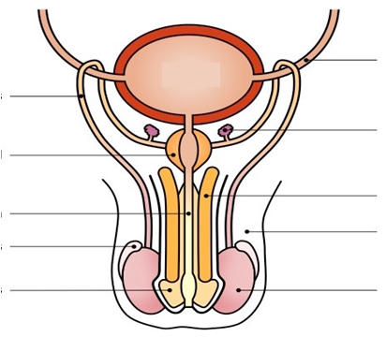

D

C

B

A

1. Identify the structures labelled A and C? (2 marks)

A: ________________________________________________________________________

C: ________________________________________________________________________

1. State the function of the structure labelled B and D (2 marks)

B: ________________________________________________________________________

________________________________________________________________________

D: ________________________________________________________________________

________________________________________________________________________

1. It is important for gametes, such as sperm, to have the chromosome number of 23.
   1. Explain the importance of having only 23 chromosomes in gametes. (2 marks)
   2. Complete the following table on the production of gametes (8 marks)

|  |  |  |
| --- | --- | --- |
|  | **Production of Sperm** | **Production of Ova** |
| **Location** |  |  |
| **When production begins** |  |  |
| **When production stops** |  |  |
| **Number of viable gametes formed from 1 parent cell** |  |  |
| **Scientific model of gamete** |  |  |

1. The production of ovum in the female productive system is controlled by four main hormones.
   1. Which hormones are involved in the beginning of puberty (1 mark)

* 1. Explain the functions of the above hormones (2 marks)

* 1. Below is a diagram where one of those cycles occurs. Label the following information on the diagram
     1. Label ovulation and ovum formation (1 mark)

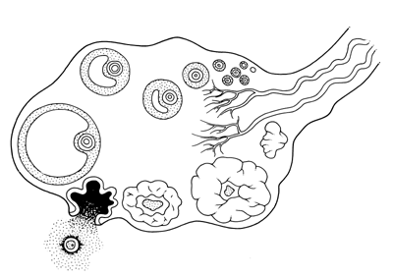

* 1. During the production of an ovum what role does Follicle Stimulating Hormone play?

(1 mark)

* 1. Which hormone is responsible for ovulation?

(1 mark)

* 1. As a result of no fertilisation, the follicle becomes Corpus Albican, explain the effect of this process. (4 marks)

***EXTENDED RESPONSE ANSWER SECTION [11 MARKS]***

***Write your answers in the space provided below:***

***You can use diagrams to support your answer***

1. Describe the pathway sperm needs to travel, from the testes where they are produced to be ejaculated out of a man. Include any organs or glands that help in the process or that sperm may pass on the way. (5 marks)

1. Males have three glands in their reproductive system. Each of the three glands produces fluid that contributes to the semen. Name the three glands and describe the role they play in the production of semen ? (6 marks)